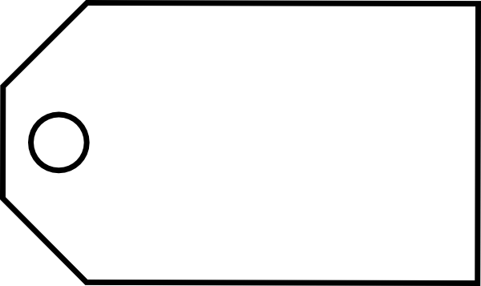
HOT WORK PERMIT
The supervisor, in issuing this permit, certifies that all safety factors have been considered and cared for satisfactorily.
Return the permit upon completion of the job to the authorizing supervisor. The supervisor will write “COMPLETE”, date and initial across the face of the permit.
^{AREA OF HOT WORK:}
^{WORK TO BE PERFORMED:}
Questions below must be answered YES or NA to proceed. | YES | NO | NA
- Hot work procedure read and understood?
- Work area and equipment free of flammable, combustible, and hazardous materials?
- Gas test completed?
- Working Fire Extinguisher on the job?
- Smoke alarms covered?
- Lines disconnected and/or blanked?
- Fire watch provided at work area with direct line of site to hot work?
- Adjoining equipment and operations considered OK from standpoint of possible effect of hot work?
- Other necessary precautions?
SPECIFY:

APPROVAL:
I have personally checked the conditions and I authorize the Hot Work to begin as indicated below:

Approved by: Date Time
Hot work permit is good for Hours Only
This permit can be issued for only one shift and becomes void at the end of the work shift.
SEE OTHER SIDE
HOT WORK PERMIT
DO NOT REMOVE THIS TAG!
TO DO SO WITHOUT AUTHORITY WILL RESULT IN DISCIPLINARY ACTION!
REMARKS:

